**\*Shweta Powar\***

**\*Assignment 6\***

1. **What is private access specifier?**

Private: The access level of a private modifier is only within the class. It cannot be accessed from outside the class. Private access specifier allows a class to hide its member variables and member functions from other functions and objects. Only functions of the same class can access its private members.

1. **what are getter and setter methods? why do we need them?**

Getters and setters are used to protect your data, particularly when creating classes. For each instance variable, a getter method returns its value while a setter method sets or updates its value. When we declare member variables as Private then we have to create Setter and getter methods to call it.

**3.why this keyword in the setter method?**

this keyword is used to avoid naming ambiguity between instance variable and local variable. it is used for calling current object.

**4.Difference between local variable and member variable/instance variable.**

|  |  |
| --- | --- |
| **Local variable** | **Instance variable** |
| A variable that is used inside the method. | A variable that is inside the class but outside the method. |
| It is not possible to use access modifiers | It is possible to use access modifiers |
| Do not have default values | Can have default values |
| Local variables create when entering a method or constructor | Instance variables create when creating an object |

**5.What is reference variable?**

A reference variable is a variable that points to an object of a given class, letting you access the value of an object. An object is a compound data structure that holds values that you can manipulate. A reference variable does not store its own values.

**6. Syntax of creating an object?**

The syntax for creating an object is:

ClassName referenceVariableName = new ClassName();

**7. Explain in detail what happens when we create an object??**

1)When an object is created, heap memory is allocated to hold the object properties.

2) An object reference variable pointing to that memory location is also created in static memory.

3)Then we can assign value to object by using reference variable which has the memory location for that particular object.

**8.What is class?**

Class is a blue print of object that follows. It is a logical entity i.e. it doesn’t have memory . It is a template used to create objects and to define object data types and methods.

**9.What is object?**

object is a member (also called an instance) of a Java class**.** It is created to call a non-static function which are not present inside the Main Method but present inside the Class and also provide the name to the space which is being used to store the data.

**10.What are the default values of all the datatypes?**

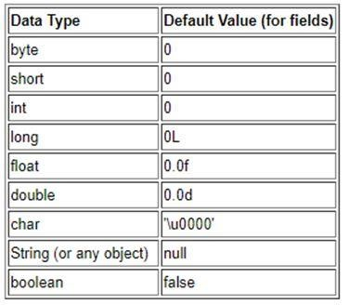

**11.Difference between the static methods and instance method?**

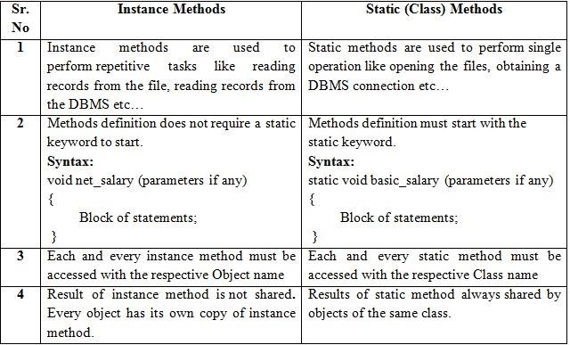

**12.Syntax of accessing the member variable in the main?**

Dot (.) operator is used to access the member variable followed by reference variable.

Syntax: referenceVariable.variableName=value;

**13.Syntax of instance method definition?**

Syntax: accessSpecifier returntype methodname( )

{

Statement;

}

**14.Syntax of static method definition?**

Syntax: accessSpecifier accessmodifier returntype methodName(arguements/parameters)

{

Statements;

}

**15.Difference between actual parameter and formal parameter?**

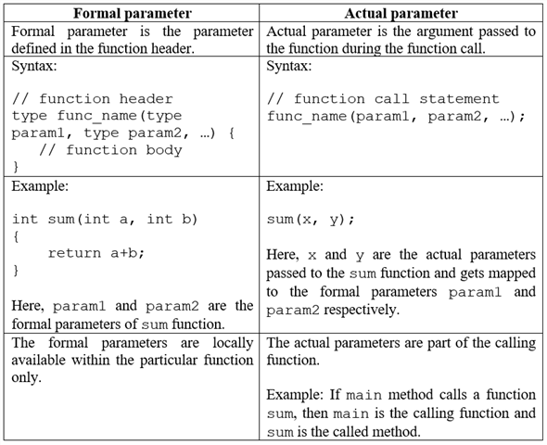

**16.Why we need the parameter or arguments to the methods?**

A parameter is a variable used to define a particular value during a function definition. Whenever we define a function we introduce our compiler with some variables that are being used in the running of that function.

An argument is a value passed to a function when the function is called. Whenever any function is called during the execution of the program there are some values passed with the function as argument.

**17.Why we need the return statement and return type to the method.**

A return statement causes the program control to transfer back to the caller of a method. Every method in Java is declared with a return type and it is mandatory for all java methods. A return type may be a primitive type like int, float, double, a reference type or void type (returns nothing)

**18.Method can be private.( true or false)?**

True, we can declare method as private in Java but it can only be accessed by the methods within the same class.